Woodside Baptist Church 2014-2015
*Dues $28.50 (First Child) $23.50 (Each Additional Child)
Puggle T-Shirt $14.50 each Puggles Handbooks $6.50 each

Cubbie Vests $14.50 each Cubbie Handbooks $11.50 each

Spark Vest $12.50 each Spark handbooks one and two $12.50 each
Spark handbook three $10.50 each
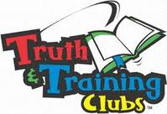
T&T t-shirt {unlimate adventure}- $15.50 each {ultimate challenge)- $16.50 each
Nice T&T shirt $20.50 each T&T handbooks one/two/three/four $11.50 each
Adult uniforms (special order--- between $21.50 and $24.50)
***All Fees must be paid by time of registration***_____________________

